**Step 1: SNS and S3 topic creation**

a.Creation of Source and target buckets

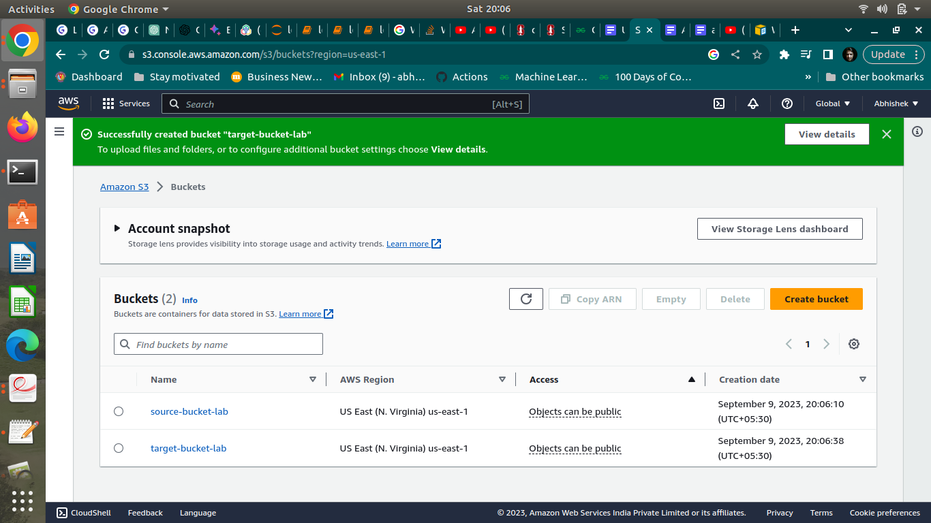

b.Creation of SNS subscription

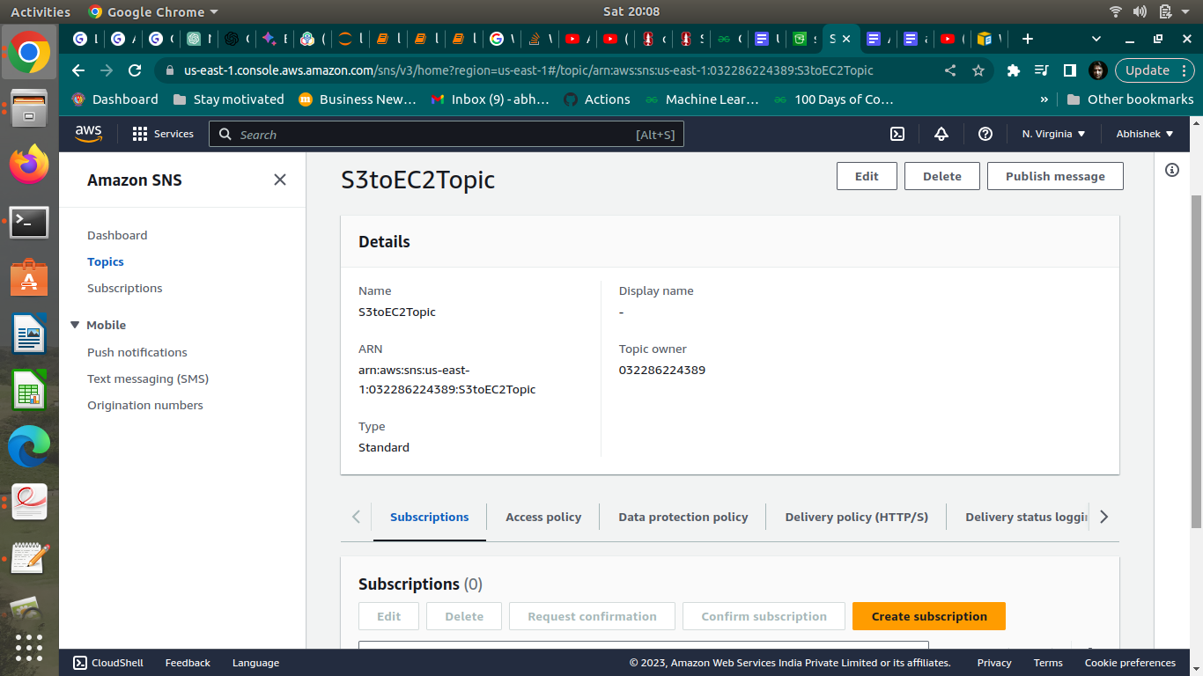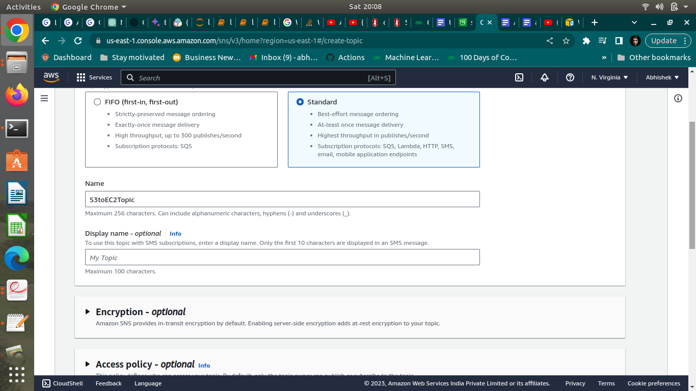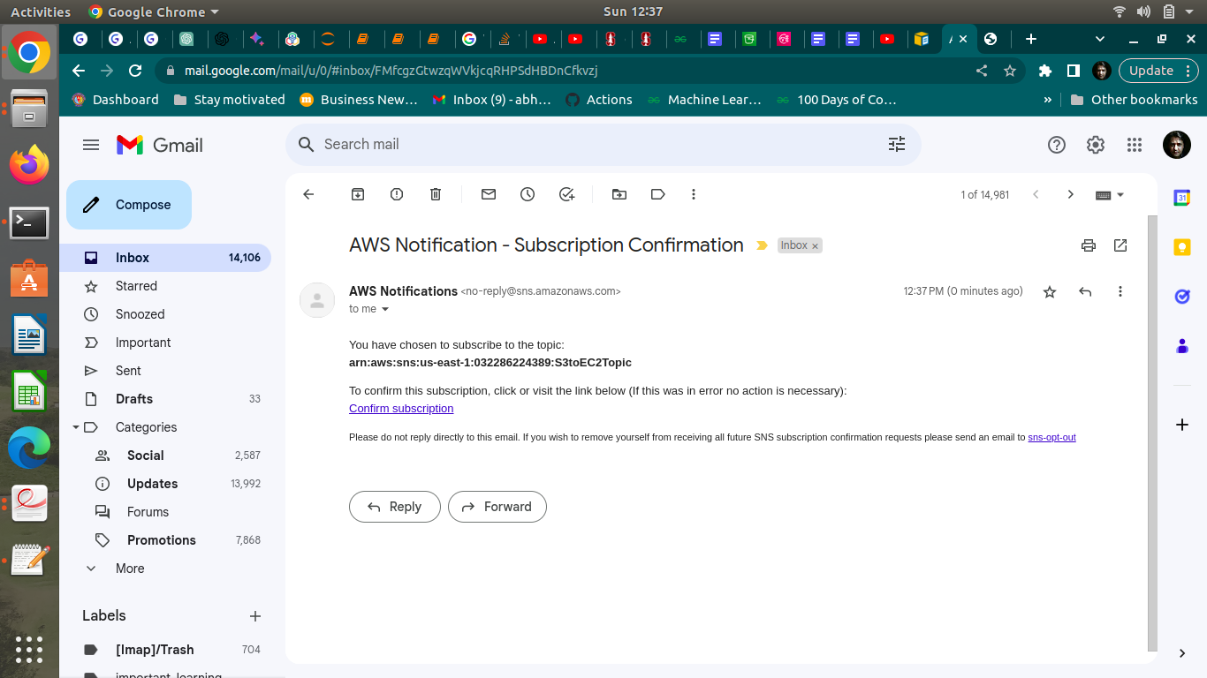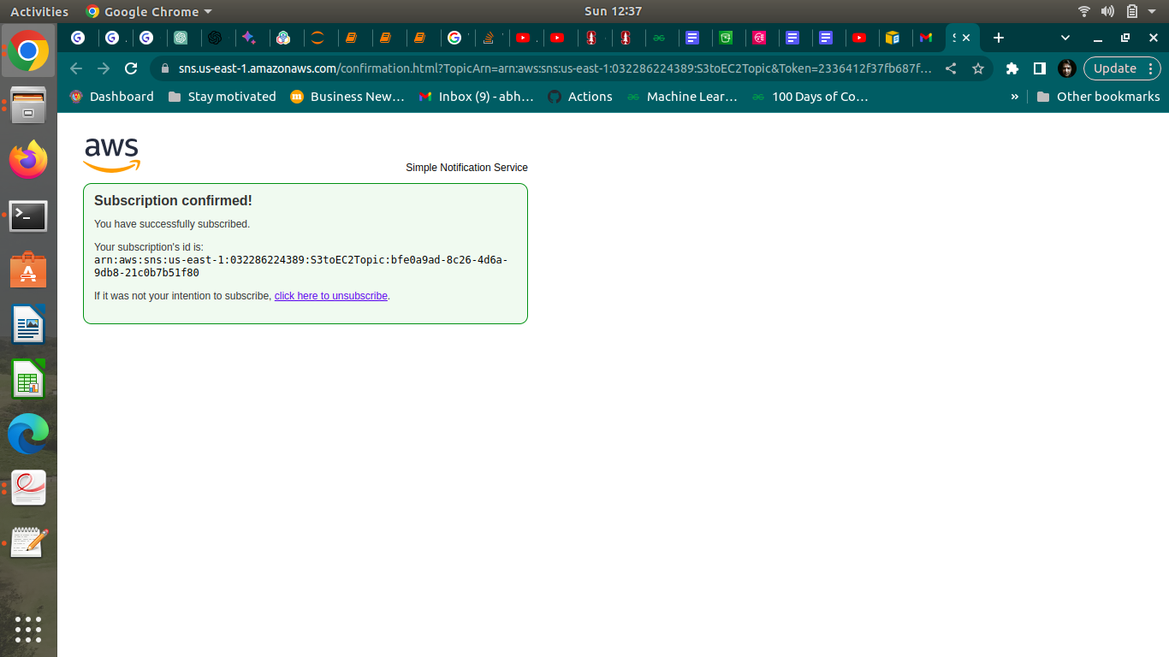

C. Modification of SNS Access Policy

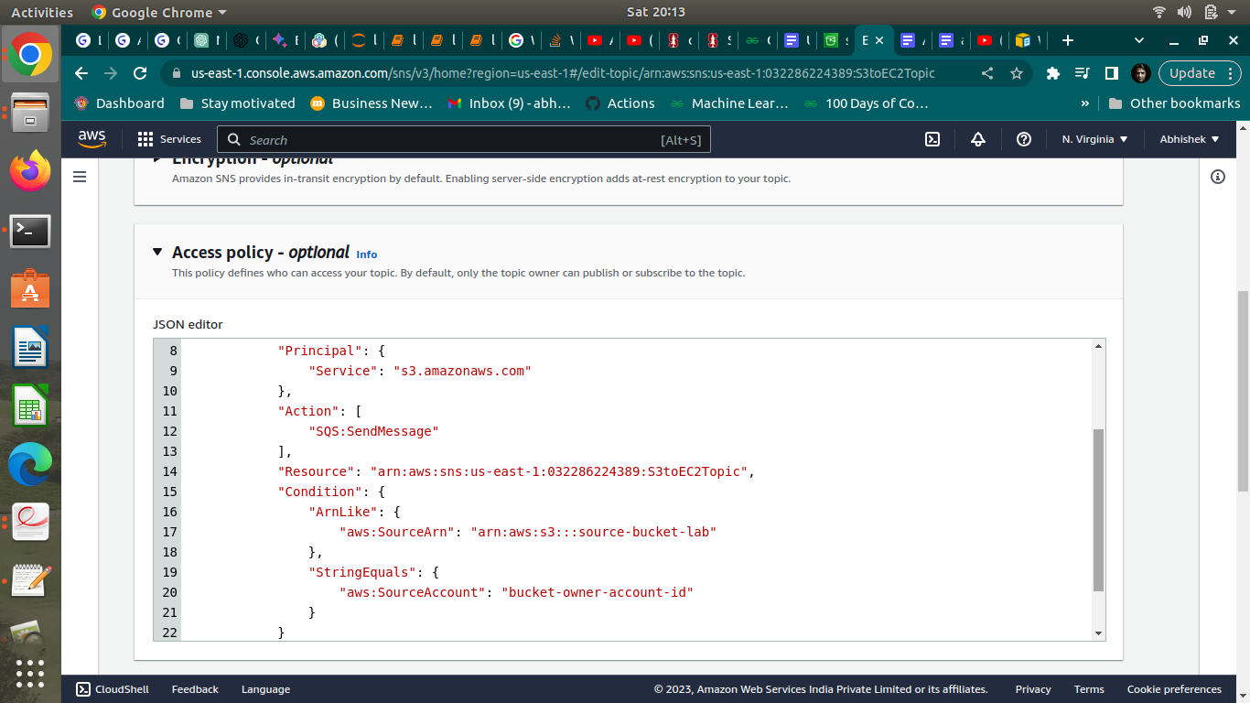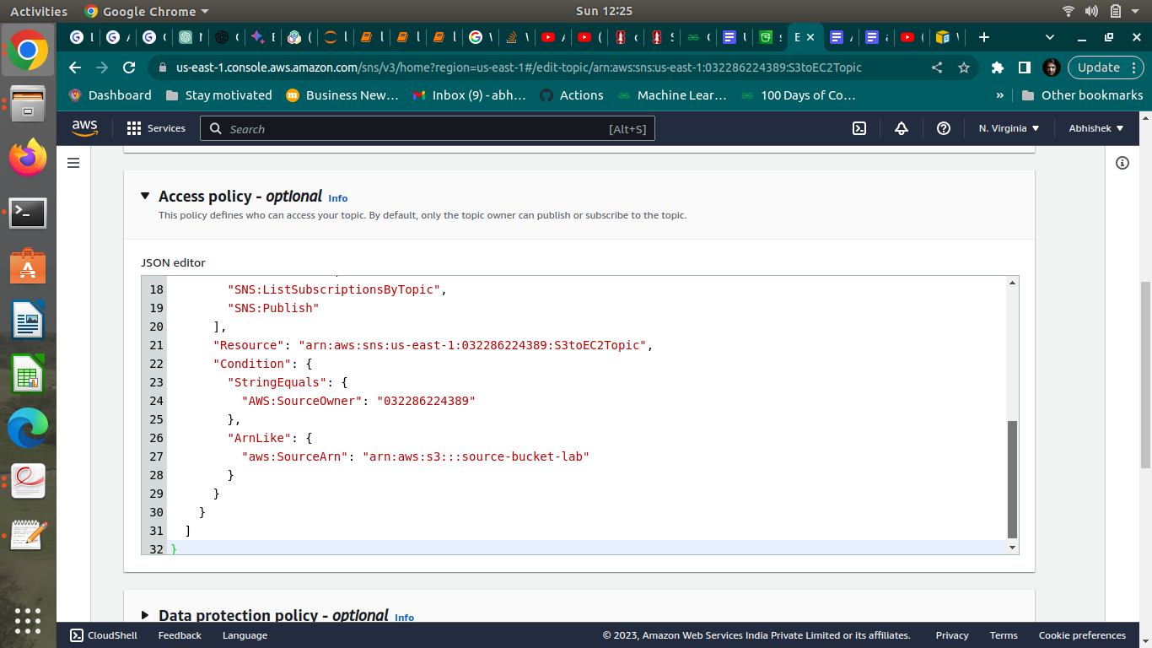

d. Configuring SNS notifications for S3

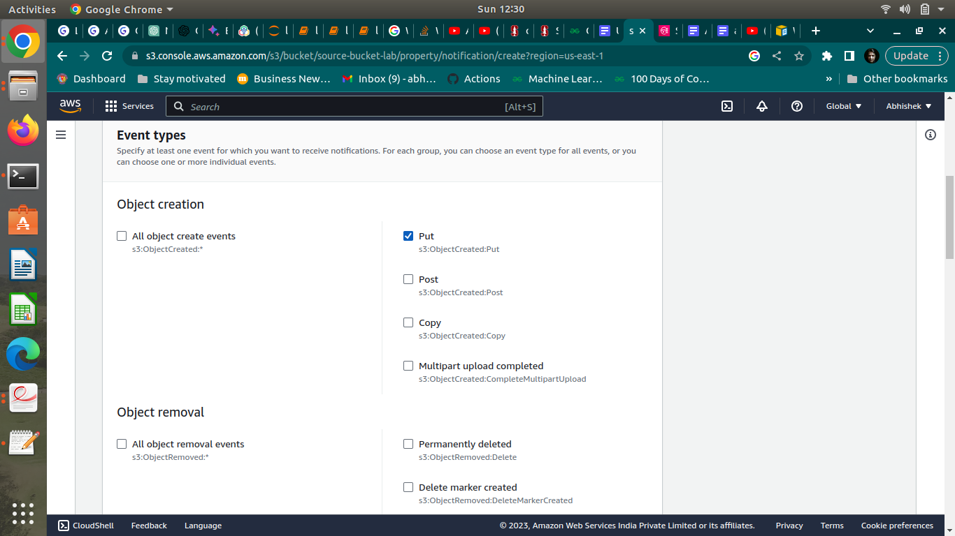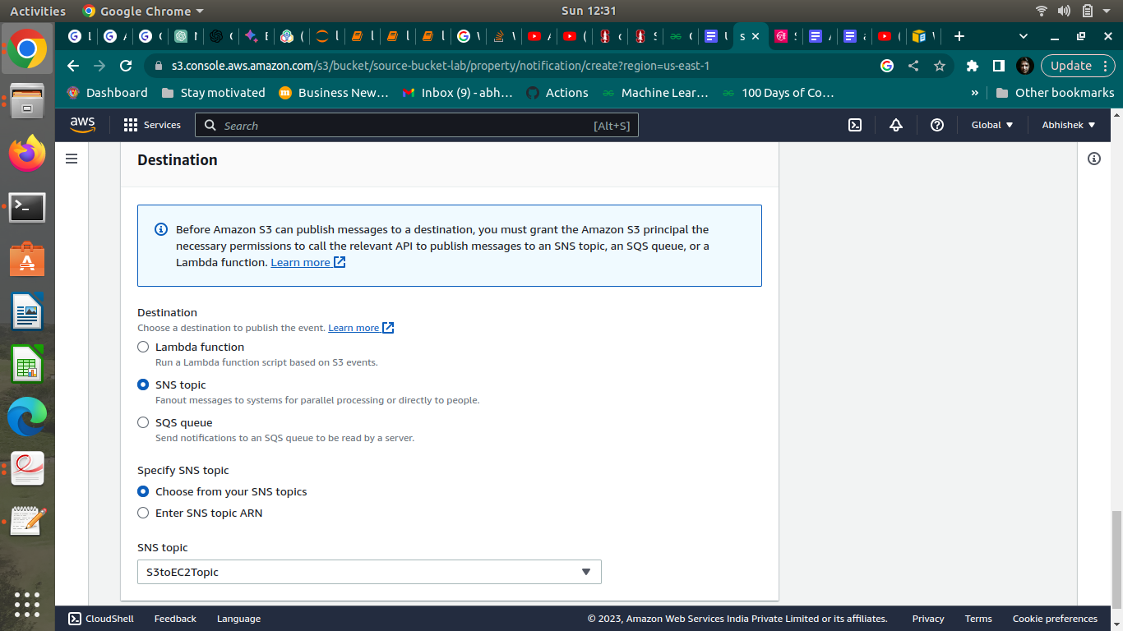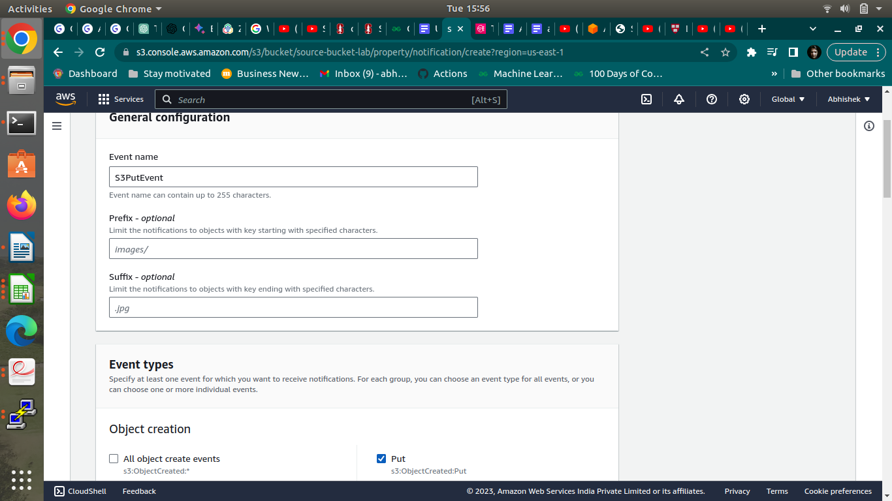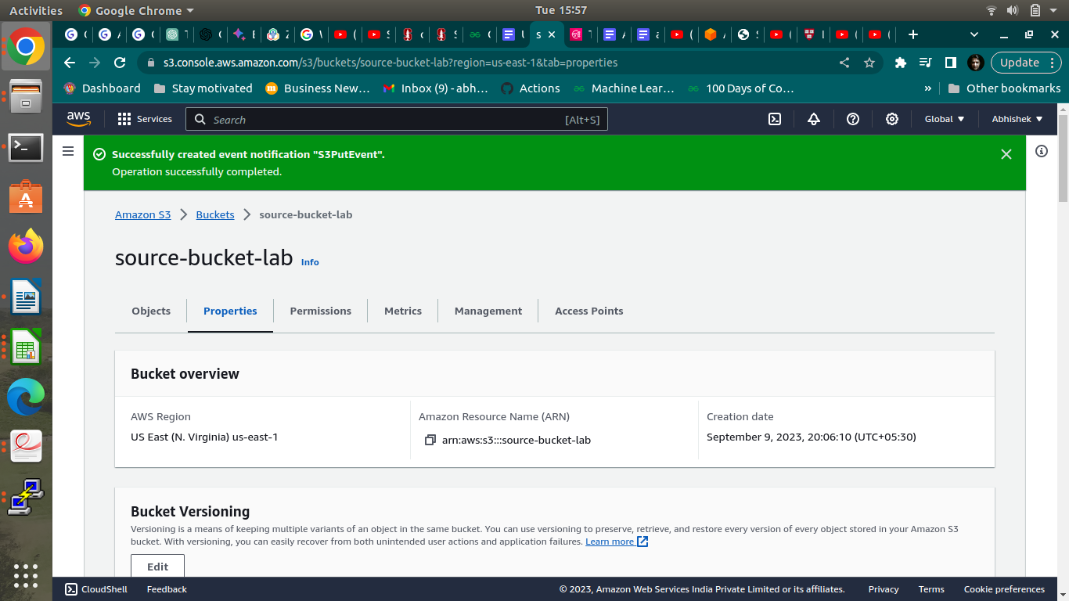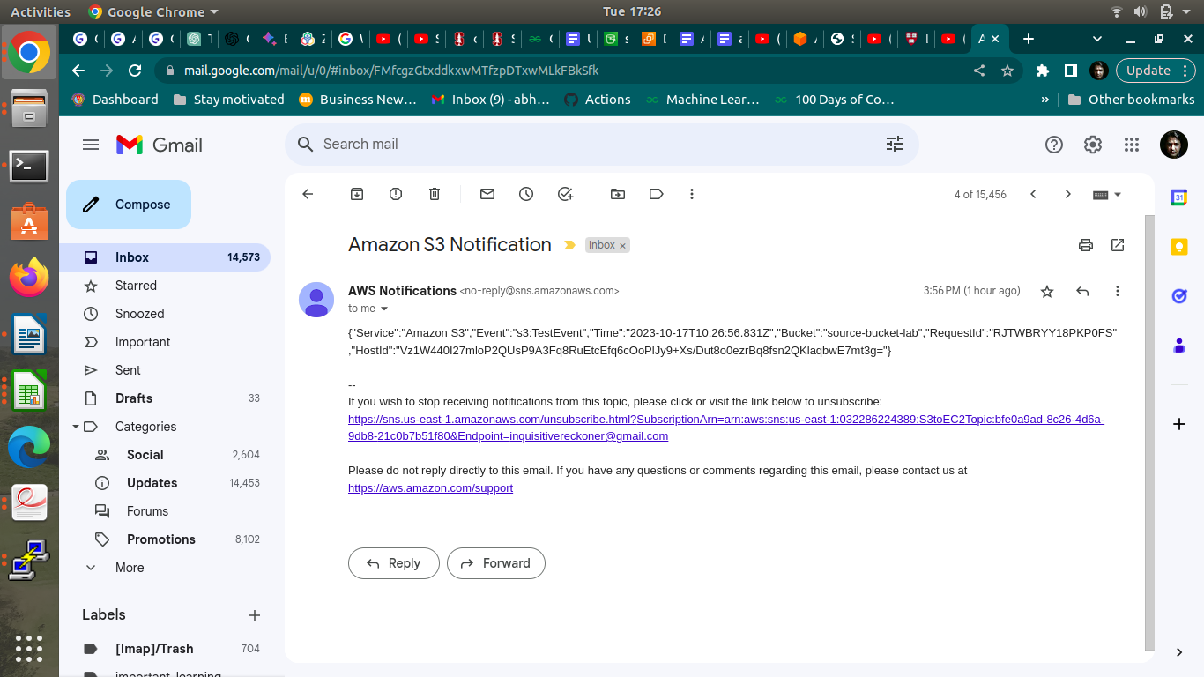

Step 2: Run the custom program in the EC2 instance

a.Creation of the EC2 instance and RDS instance

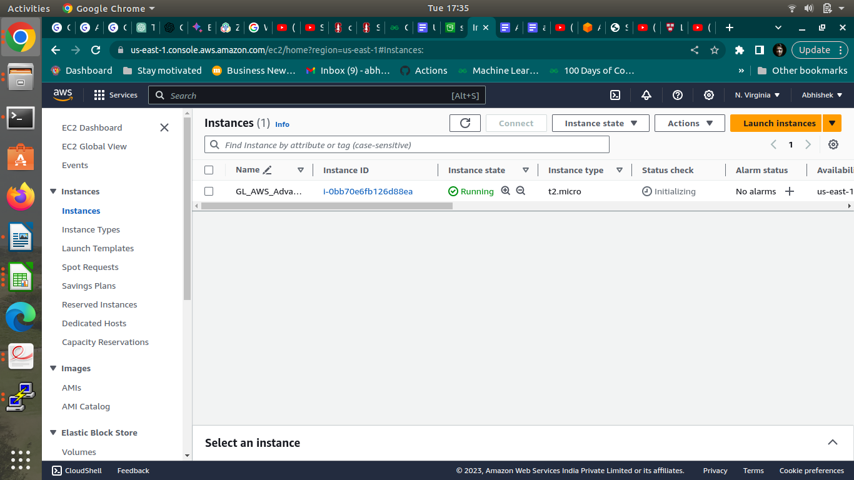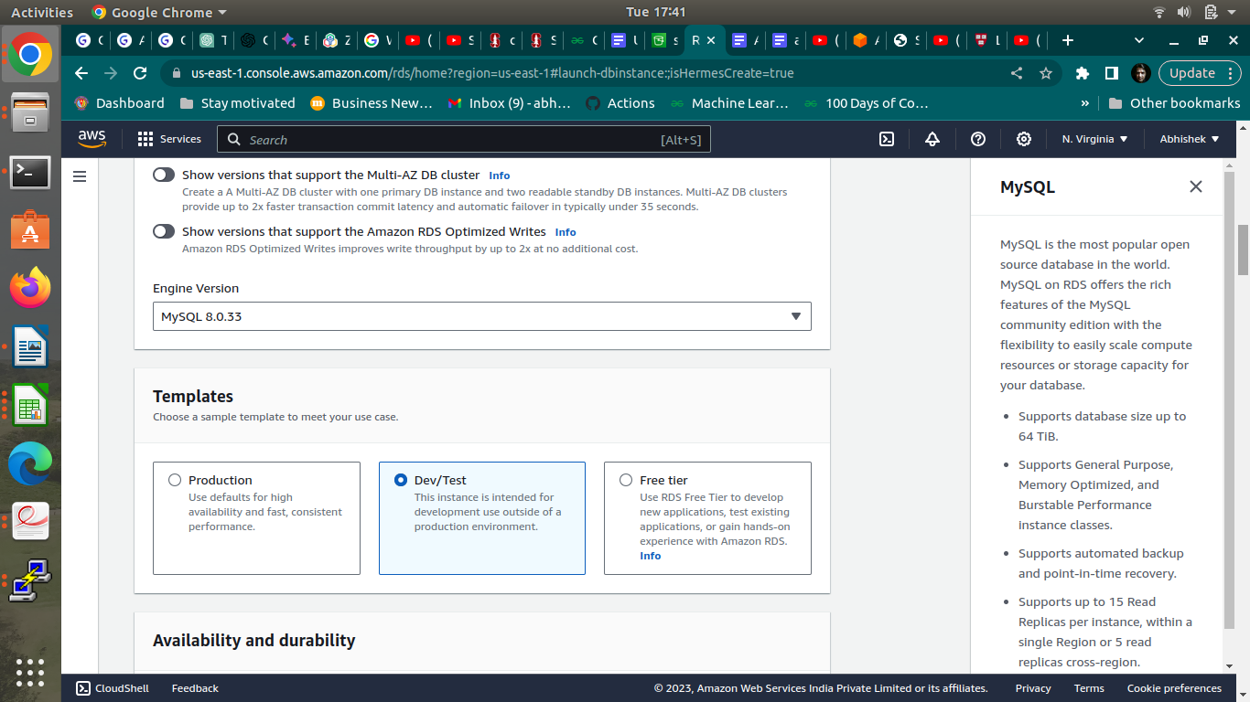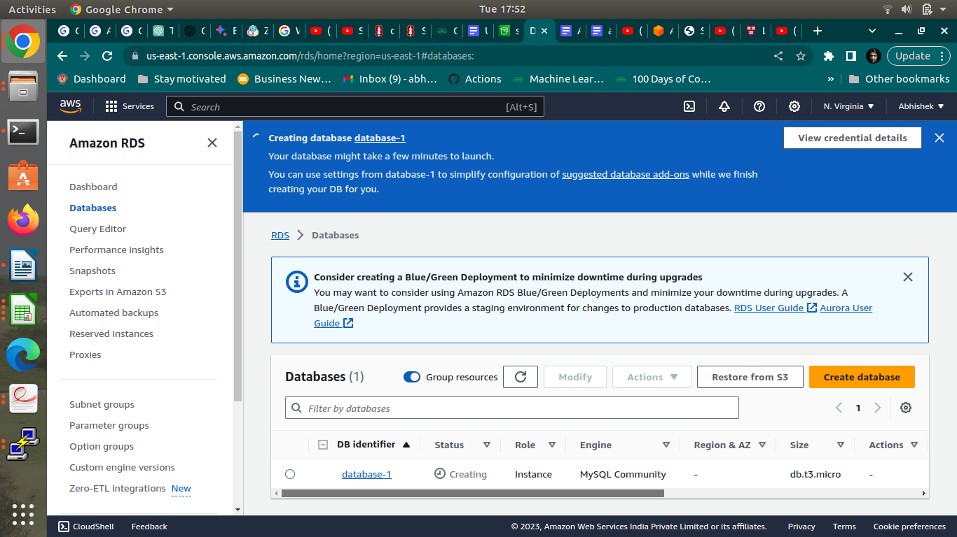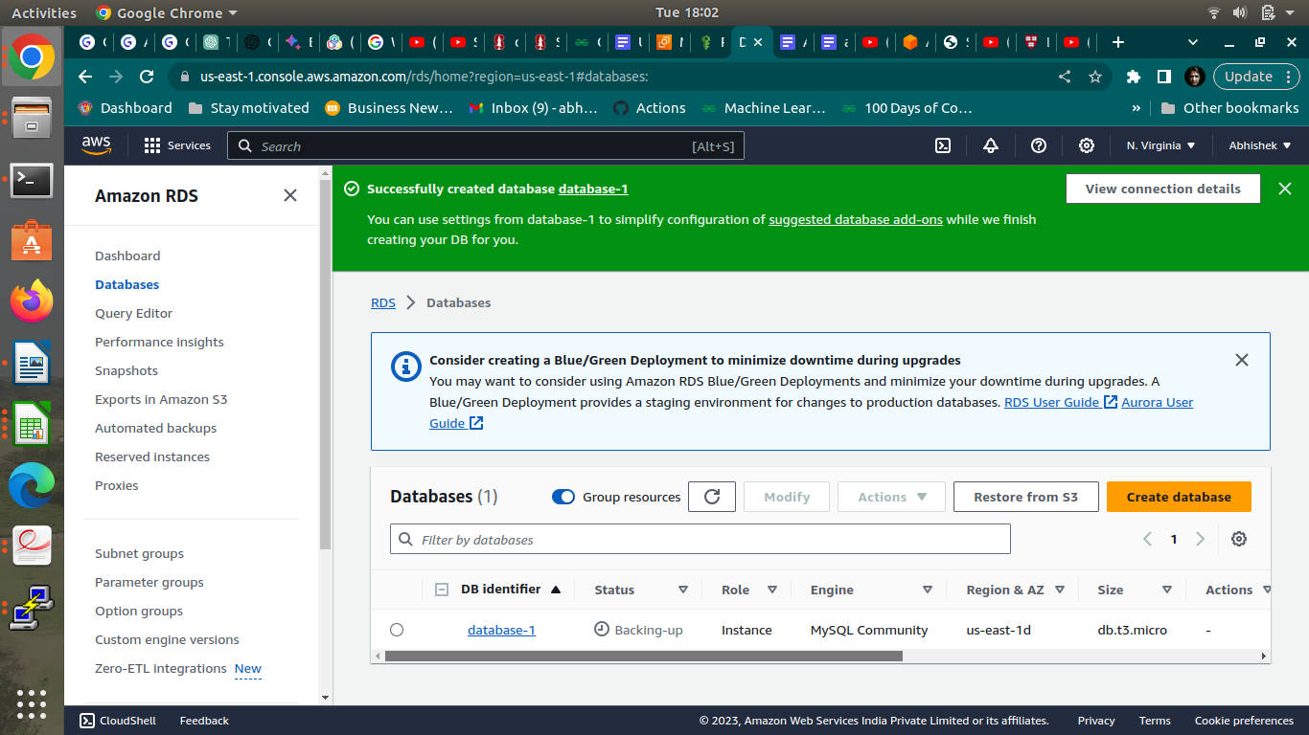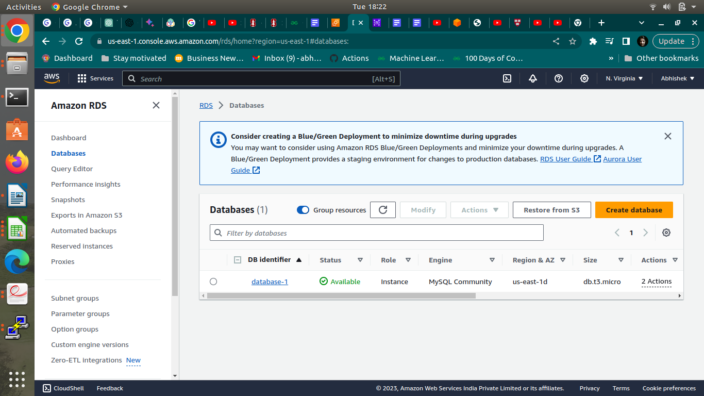

b.Assignment of IAM role for EC2 instance

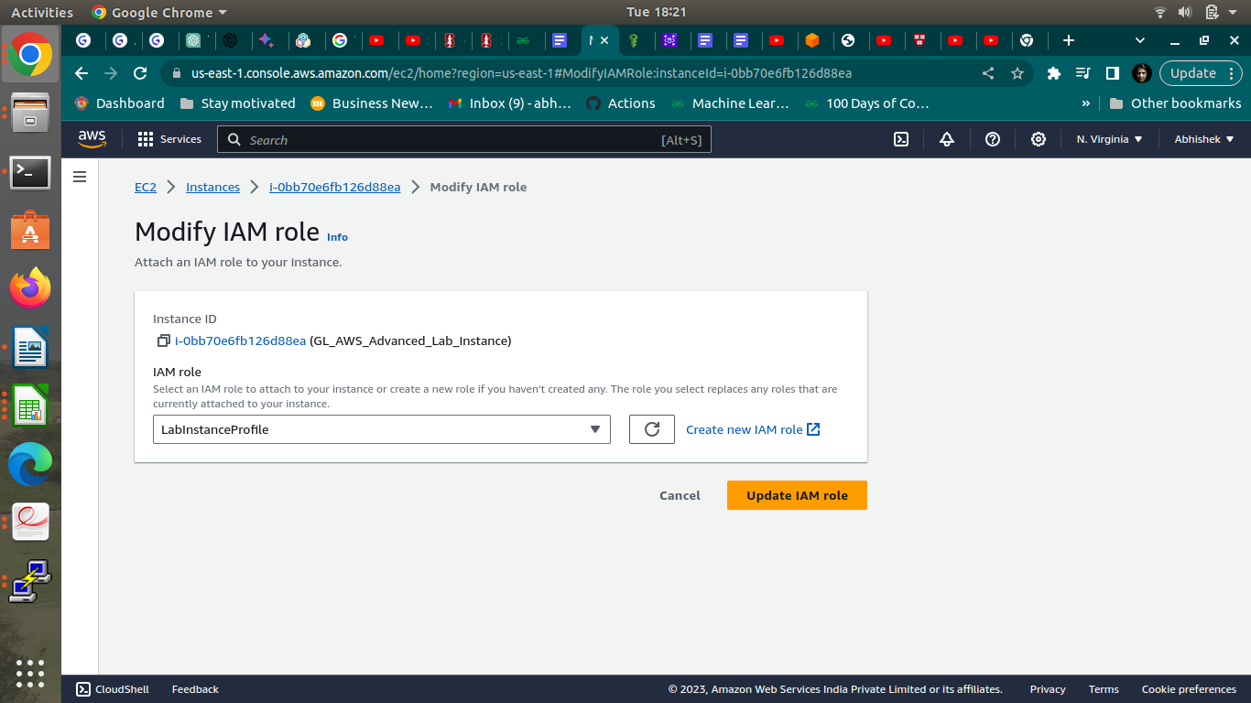

c.Configuration and Uploading of custom program

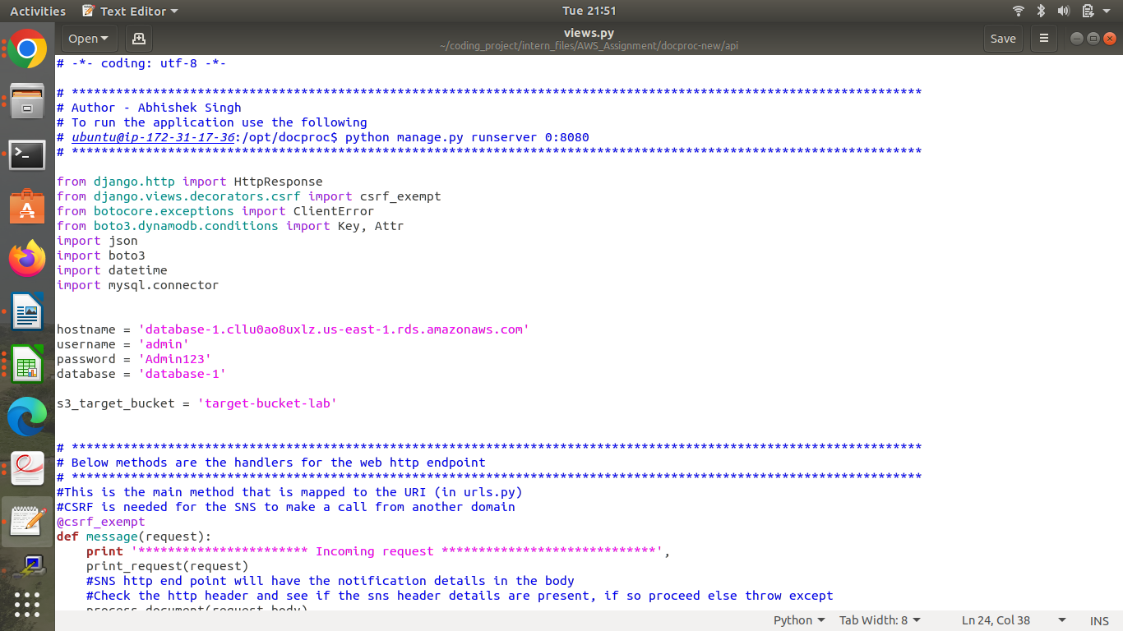

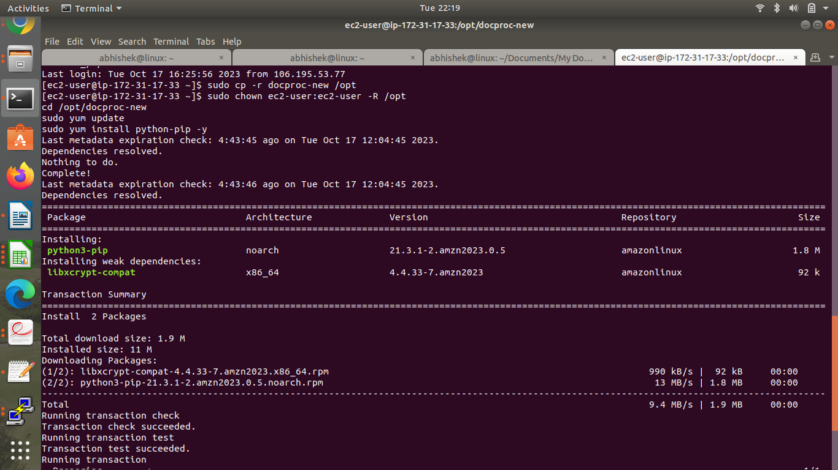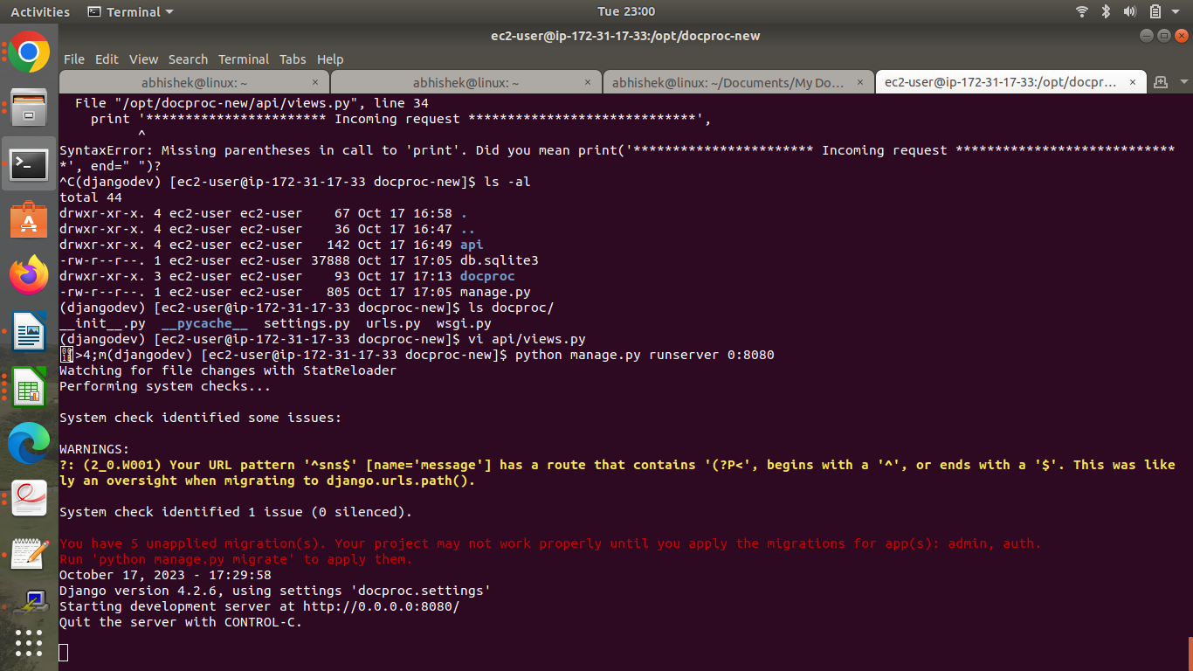

Step 3: Creation and Verification of SNS subscription and Generation of CSV file

1. Starting the EC2 custom program

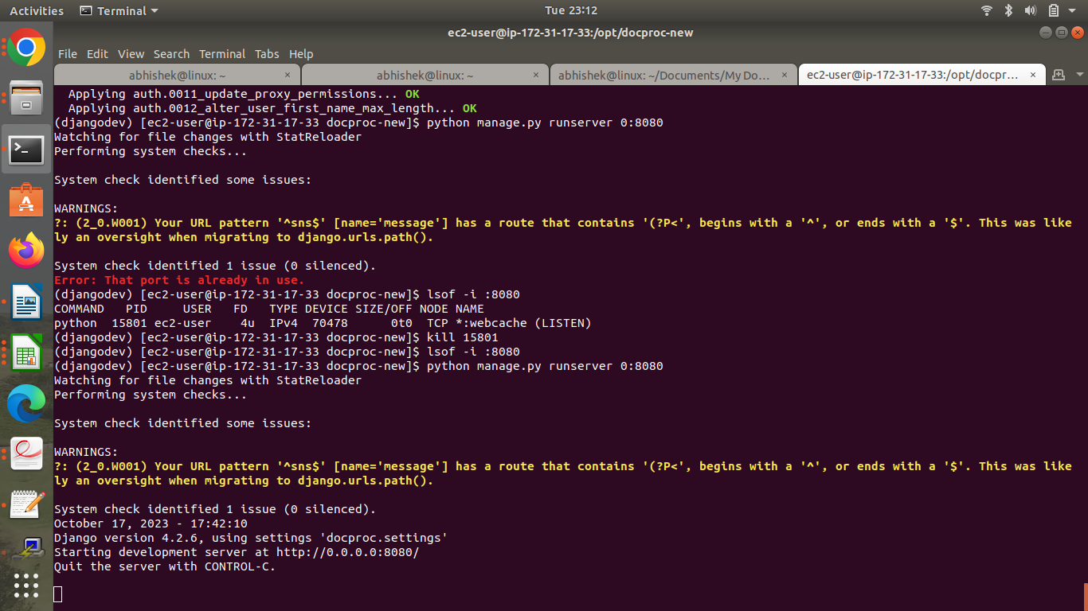

1. Creation of SNS subscription

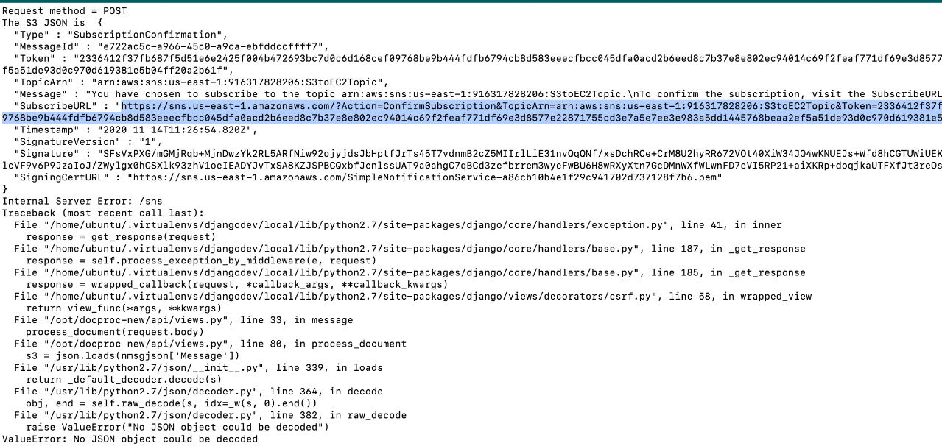

1. Generation of CSV file

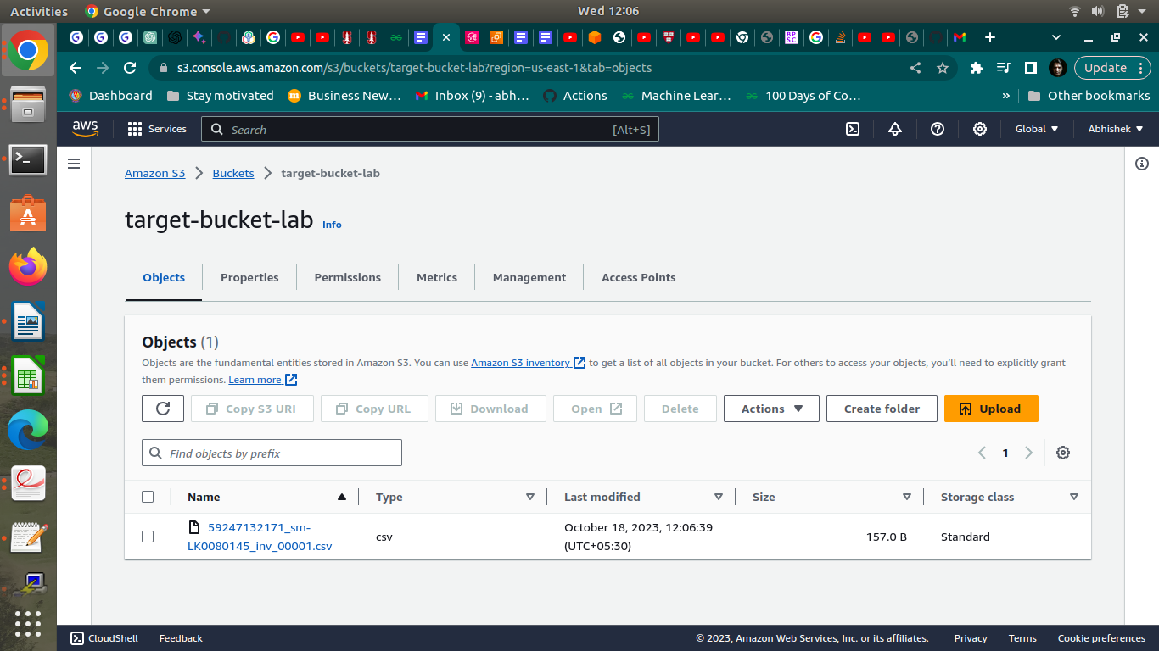

**Answer the following questions**

**Q1:**

**Which of the following properties of an AWS resource is sufficient and necessary**

**to uniquely identify it across all of AWS?**

a) ARN

b) Region and ARN

c) ARN and Account number

d) Depends on the resource used

Enter your answer here :

| **a** |
| --- |

**Q2**

**Which of the following step numbers in Step 1 allowed S3 to publish to the SNS**

**topic created?**

a) 1(a)

b) 1(c)

c) 1(d)

d) 1(b)

Enter your answer here

| **b** |
| --- |

**Q3**

**Which port is being used by SNS to send the notification to the custom program?**

a) 8081

b) 80

c) 8080

d) 8065

Enter your answer here:

| **c** |
| --- |

**Q4**

**How many IAM roles can be attached to an EC2 instance at a time?**

a) 2

b) 3

c) 1

d) Depends on the policies required

Enter your answer here

| **c** |
| --- |

**Q5**

**As a product manager, how would you describe the benefits of this architecture to**

**an client, as compared to an equivalent on-premises architecture?**

**Suggestion:**

This cloud architecture offers several benefits over an equivalent on-premises setup. It provides built-in triggers for seamless event management, facilitating efficient coordination between storage and computing resources. The architecture incorporates a built-in messaging service, streamlining communication between components. Moreover, it leverages a managed database service, eliminating the complexities associated with database administration. These advantages enhance scalability, flexibility, and overall operational efficiency for the client, making it a more dynamic and resource-efficient solution compared to traditional on-premises architectures.